**Project : Co-Working**

**Space-Room**

**กลุ่มที่ 16**

**นาย ปิติภาคย์ 6204062610091**

**นาย กริช 6204062620151**

**เสนอ**

**อาจารย์ กอบเกียรติ สระอุบล**

**รายงานฉบับนี้เป็นส่วนหนึ่งของวิชา**

**การโปรแกรมคอมพิวเตอร์ 1**

**(040613102)**

**Description**

**เพื่อตอบสนองความต้องการพื้นฐานของลูกค้าที่เข้ามาใช้บริการ Co-Working-Space-Room ตามร้านคาเฟ่ขนาดใหญ่ และ หอหนังสือ ในเขตกรุงเทพและปริมณฑล เพื่อคนที่ต้องการใช้ห้องในการประชุม ทำงาน หรือ พักพ่อน**

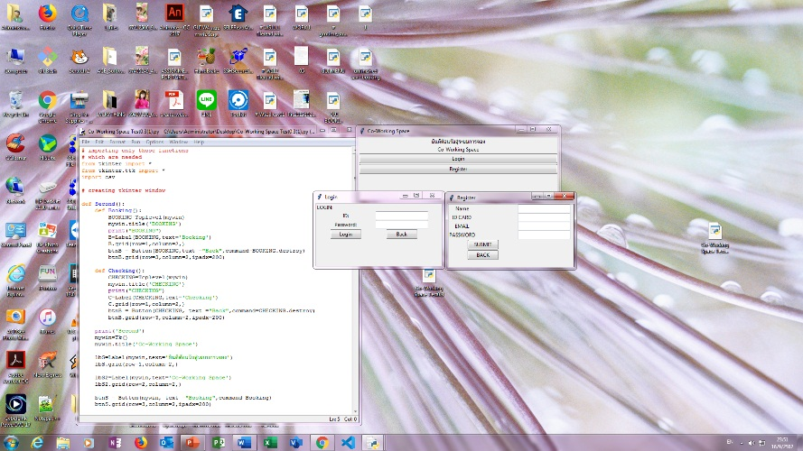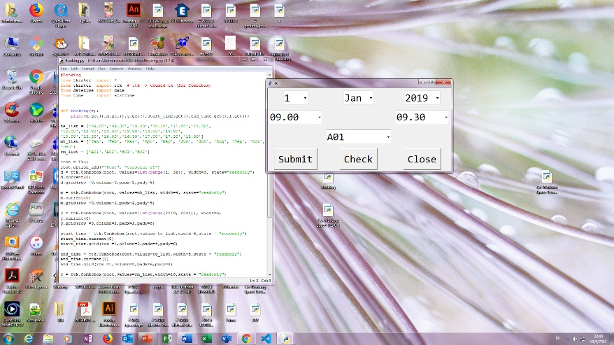**User-Interface**

**Flowchart**

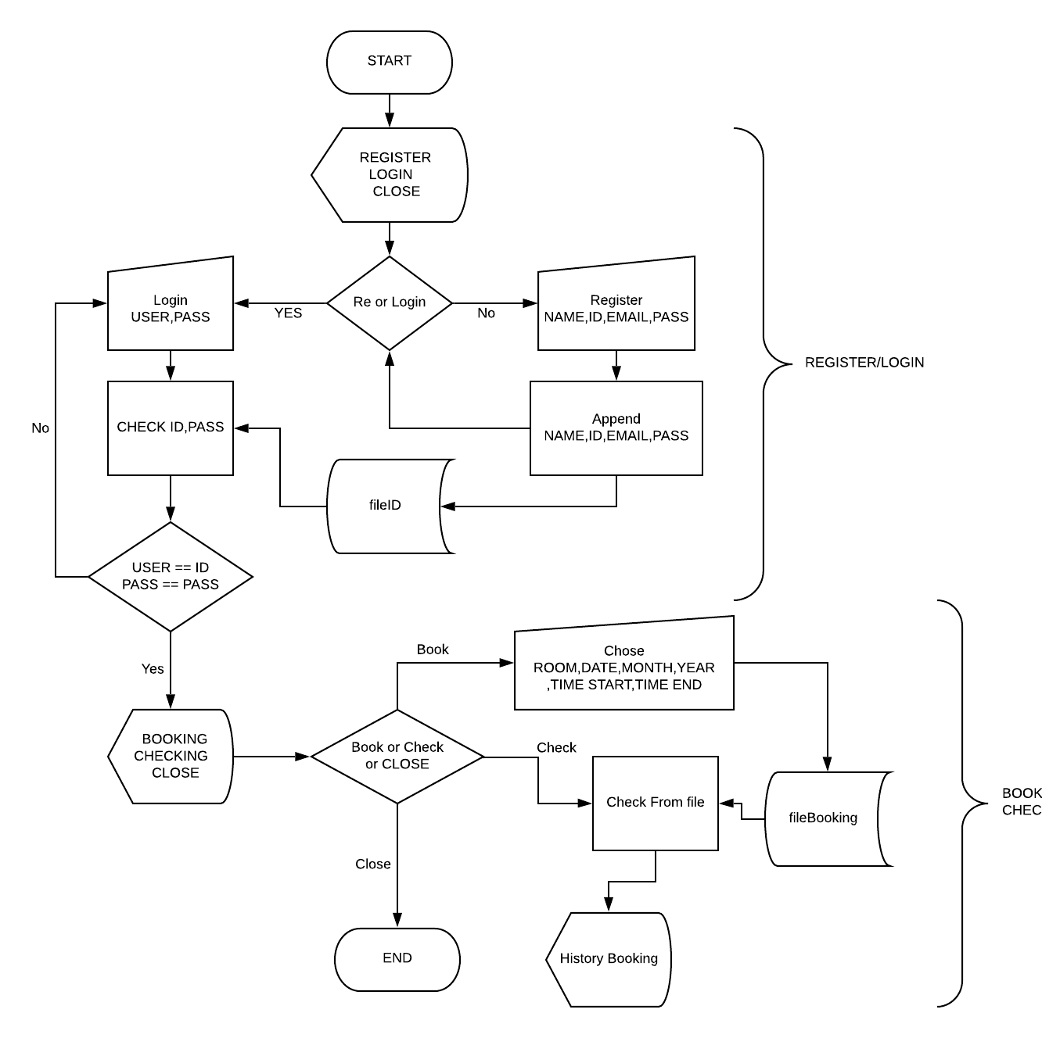

**Input-Output**

**ระบบลงทะเบียนและระบบการจอง**

**-ข้อมูลผู้เข้าใช้**

**ระบบจอง Co-Working Space Room  
-วันเวลา,จำนวนชั่วโมงและห้องที่จอง**

**List**

**[ID,NAME,EMAIL,PASS,ROOM,DAY  
,MONTH,YEAR,TIME ST-ED]**

**Data File  
FileID = [[ID,NAME,EMAIL,PASS]]**

**FileBooking = [[ID,NAME,EMAIL,PASS,DAY,MONTH,YEAR,TIME ST-ED]]**

**Python Codes**

**# importing only those functions**

**# which are needed**

**from tkinter import \***

**from tkinter.ttk import \***

**import csv**

**# creating tkinter window**

**def Second():**

**def Booking():**

**def SUMMIT():**

**filepath='fileID.csv'**

**with open(filepath,"r",encoding='utf-8')as infile:**

**rd=csv.reader(infile)**

**mylist=list(rd)**

**print('Check FileID :',mylist)**

**R=ROOM.get()**

**D=DAY.get()**

**M=MONTH.get()**

**Y=YEAR.get()**

**S=START.get()**

**E=END.get()**

**for lst in mylist:**

**print(lst)**

**if USER in lst and PASS in lst:**

**print('---Correct---')**

**print("CHECKING BOOKING:",R,D,M,Y,S,'to',E)**

**lst.append(R)**

**lst.append(D)**

**lst.append(M)**

**lst.append(Y)**

**lst.append(S)**

**lst.append(E)**

**print(lst)**

**lst1=[]**

**lst1.append(lst)**

**print(lst1)**

**fileB='fileBooking.csv'**

**with open(fileB,"a",encoding='utf-8')as outfile:**

**writer=csv.writer(outfile,lineterminator='\n')**

**writer.writerows(lst1)**

**break**

**else:**

**print('---Nope---')**

**MONTHS_LIST = ['Jan','Feb','Mar','Apr','May','Jun','Jul','Aug','Sep','Oct','Nov','Dec']**

**ROOM_LIST = ['R01','R02','B01','B02']**

**TIME_LIST = ['09.00','10.00','11.00','12.00','13.00','14.00','15.00','16.00','17.00','18.00']**

**TIME_LIST2 = ['10.00','11.00','12.00','13.00','14.00','15.00','16.00','17.00','18.00']**

**BOOKING=Toplevel(mywin)**

**BOOKING.title('BOOKING')**

**print("BOOKING")**

**global ROOM**

**global DAY**

**global MONTH**

**global YEAR**

**lb=Label(BOOKING,text='ROOM')**

**lb.grid(row=0,column=0)**

**ROOM=Combobox(BOOKING,values=ROOM_LIST,state="readonly")**

**ROOM.current(0)**

**ROOM.grid(row=1,column=0)**

**lb=Label(BOOKING,text='DAYS')**

**lb.grid(row=0,column=1)**

**DAY=Combobox(BOOKING,values=list(range(1, 32)),state="readonly")**

**DAY.current(0)**

**DAY.grid(row=1,column=1)**

**lb=Label(BOOKING,text='MONTHS')**

**lb.grid(row=0,column=2)**

**MONTH=Combobox(BOOKING,values=MONTHS_LIST,state="readonly")**

**MONTH.current(0)**

**MONTH.grid(row=1,column=2)**

**lb=Label(BOOKING,text='YEARS')**

**lb.grid(row=0,column=3) YEAR=Combobox(BOOKING,value=list(range(2019,2023)),state="readonly")**

**YEAR.current(0)**

**YEAR.grid(row=1,column=3)**

**lb=Label(BOOKING,text='START')**

**lb.grid(row=0,column=4)**

**START=Combobox(BOOKING,value=TIME_LIST,state="readonly")**

**START.current(0)**

**START.grid(row=1,column=4)**

**lb=Label(BOOKING,text='END')**

**lb.grid(row=0,column=5)**

**END=Combobox(BOOKING,value=TIME_LIST2,state="readonly")**

**END.current(0)**

**END.grid(row=1,column=5)**

**btn=Button(BOOKING,text="SUMMIT",command=SUMMIT)**

**btn.grid(row=2,column=0)**

**btn = Button(BOOKING,text ="Back",command=BOOKING.destroy)**

**btn.grid(row=2,column=1)**

**def Checking():**

**CHECKING=Toplevel(mywin)**

**CHECKING.title('HISTORY')**

**print("HISTORY")**

**fileH='fileBooking.csv'**

**with open(fileH,"r",encoding='utf-8')as infile:**

**rd=csv.reader(infile)**

**mylist=list(rd)**

**print(mylist)**

**i=0**

**for lst in mylist:**

**print(lst)**

**if USER == lst[0]:**

**i+=1**

**print(i)**

**P=(lst[4],lst[5],lst[6],lst[7],lst[8],'-',lst[9])**

**C=Label(CHECKING,text=P)**

**C.grid(row=+i,column=1,)**

**print('---THIS ONE---')**

**else:**

**print('---Not This---')**

**C=Label(CHECKING,text='Checking')**

**C.grid(row=0,column=1,)**

**btnB = Button(CHECKING, text ="Back",command=CHECKING.destroy)**

**btnB.grid(row=3,column=2,)**

**print('USER :',USER)**

**print('PASS :',PASS)**

**print('Second')**

**mywin=Tk()**

**mywin.title('Co-Working Space')**

**lbS=Label(mywin,text='ยินดีต้อนรับสู่ระบบการจอง')**

**lbS.grid(row=1,column=2,)**

**lbS2=Label(mywin,text='Co-Working Space')**

**lbS2.grid(row=2,column=2,)**

**btnS = Button(mywin, text ="Booking",command=Booking)**

**btnS.grid(row=3,column=2,ipadx=200)**

**btnS2 = Button(mywin, text ="Checking",command=Checking)**

**btnS2.grid(row=4,column=2,ipadx=200)**

**btnS3 = Button(mywin, text ="Close",command=mywin.destroy)**

**btnS3.grid(row=5,column=2,ipadx=200)**

**def Login():**

**def Check():**

**for lst in mylist:**

**global USER**

**global PASS**

**USER=str(myUSER.get())**

**PASS=str(myPASS.get())**

**print('Check ID : ',USER)**

**print('Check PASS: ',PASS)**

**print('Check lst :',lst)**

**D=lst[0]**

**P=lst[3]**

**checkID=[]**

**if USER == D and PASS == P:**

**print('----CORRECT----')**

**Second()**

**Login.destroy()**

**mywin.destroy()**

**break**

**else:**

**print('----NOPE----')**

**try:**

**print(checkID[0])**

**except IndexError:**

**lb=Label(Login,text='Some ID or PASSS wrong ')**

**lb.grid(row=0,column=1)**

**try:**

**filepath='fileID.csv'**

**with open(filepath,"r",encoding='utf-8')as infile:**

**rd=csv.reader(infile)**

**mylist=list(rd)**

**except :**

**print('WTF')**

**global myUSER**

**global myPASS**

**myUSER=StringVar()**

**myPASS=StringVar()**

**Login=Toplevel(mywin)**

**Login.title('Login')**

**Login.minsize(300,150)**

**lb=Label(Login,text='LOGIN:')**

**lb.grid(row=0,column=0,ipadx=50)**

**lb=Label(Login,text='ID/USER:') #ID**

**lb.grid(row=1,column=0)**

**USER=Entry(Login,textvariable=myUSER)**

**USER.grid(row=1,column=1)**

**lb=Label(Login,text='Password:') #PASS**

**lb.grid(row=2,column=0)**

**PASS=Entry(Login,textvariable=myPASS)**

**PASS.grid(row=2,column=1)**

**btok=Button(Login,text='Login',command=Check)**

**btok.grid(row=3,column=0)**

**btok=Button(Login,text='Back',command=Login.destroy)**

**btok.grid(row=3,column=1)**

**def Register():**

**def Save():**

**import csv**

**lst=[]**

**lst1=[]**

**NAME=str(myNAME.get())**

**ID=str(myID.get())**

**EMAIL=str(myEMAIL.get())**

**PASS=str(myPASS.get())**

**print('Save')**

**lst.append(ID)**

**lst.append(NAME)**

**lst.append(EMAIL)**

**lst.append(PASS)**

**print('all save to lst')**

**print(lst)**

**lst1.append(lst)**

**print('[lst] to lst1')**

**print(lst1)**

**fileID='fileID.csv'**

**with open(fileID,"a",encoding='utf-8')as outfile:**

**writer=csv.writer(outfile,lineterminator='\n')**

**writer.writerows(lst1)**

**print('lst1 has added')**

**Register.destroy()**

**Register=Toplevel(mywin)**

**Register.title('Register')**

**Register.minsize(300,150)**

**global NAME**

**global myNAME**

**global ID**

**global myID**

**global PASS**

**global myPASS**

**global EMAIL**

**global myEMAIl**

**myNAME=StringVar()**

**myID=StringVar()**

**myEMAIL=StringVar()**

**myPASS=StringVar()**

**lb=Label(Register,text='Name') #Name**

**lb.grid(row=1,column=2,ipadx=50)**

**NAME=Entry(Register,textvariable=myNAME)**

**NAME.grid(row=1,column=3)**

**lb=Label(Register,text='ID CARD') #ID**

**lb.grid(row=2,column=2,ipadx=50)**

**ID=Entry(Register,textvariable=myID)**

**ID.grid(row=2,column=3)**

**lb=Label(Register,text='EMAIL') #EMAIL**

**lb.grid(row=3,column=2,ipadx=50)**

**EMAIL=Entry(Register,textvariable=myEMAIL)**

**EMAIL.grid(row=3,column=3)**

**lb=Label(Register,text='PASSWORD') #PASSWORD**

**lb.grid(row=4,column=2,ipadx=50)**

**PASS=Entry(Register,textvariable=myPASS)**

**PASS.grid(row=4,column=3)**

**btok=Button(Register,text='SUMMIT',command=Save) #use def Save**

**btok.grid(row=11,column=2)**

**bt=Button(Register,text='BACK',command=Register.destroy) #Close**

**bt.grid(row=12,column=2)**

**global mywin**

**mywin = Tk()**

**mywin.minsize(300,150)**

**print('First')**

**mywin.title('Co-Working Space')**

**lbF=Label(mywin,text='ยินดีต้อนรับสู่ระบบการจอง')**

**lbF.grid(row=1,column=2,)**

**lbF2=Label(mywin,text='Co-Working Space')**

**lbF2.grid(row=2,column=2,)**

**btnF = Button(mywin, text ="Login",command=Login)**

**btnF.grid(row=3,column=2,ipadx=200)**

**btnF2 = Button(mywin, text ="Register",command=Register)**

**btnF2.grid(row=4,column=2,ipadx=200)**

**mainloop()**

**# infinite loop**